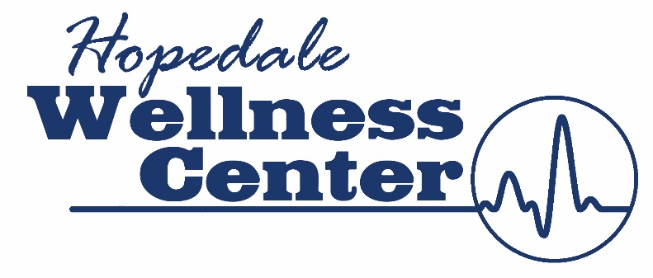

Hopedale Wellness Center
COVID Policy Extension as of September 6, 2021

Current Guidelines: Extended to October 10, 2021
Mandatory Masking Policy (Mandated by the State of Illinois) is extended until we are directed otherwise by the state.
We must follow the rules and regulations set forth as the Wellness Center is a part of a healthcare facility. We provide Physical Therapy, Cardiac Rehabilitation and Pulmonary Rehabilitation services along with an open membership to our communities.

Due to the increase of positive COVID cases and the delta variant in Tazewell County and the surrounding areas of Hopedale, it is the policy of the Hopedale Medical Complex and all its entities per the Illinois Department of Health to initiate safety strategies for all Wellness Center members, guests, and patients. These strategies will continue as of September 6, 2021. These strategies are in place to protect our members, patients and guests from a possible exposure and help reduce the potential rise of covid cases.

Policies:
- ALL persons that enter the Wellness Center MUST always wear a mask (you are responsible for bring your own mask).

- As there will be consistent cleaning throughout the day, the Wellness Center will be deep cleaning and disinfecting with electrostatic spray (which has a temporary smell to it but dries fast).
- Monday – Friday 12:00 – 1:00 Sunday at Closing
Fitness Floor:
- If you are on a cardio machine and are socially distanced apart from others (6 feet), you may take off your mask to exercise. Once you complete your exercise, your mask must immediately go back on while walking through the facility.

- If you are on a weight machine and are socially distanced apart from others (6 feet), you may take off your mask to exercise. Once you complete your exercise, your mask must immediately go back on while walking through the facility.

- If you are walking around the track when others are walking, you need to be wearing a mask. If there are no other walkers on the track or socially distanced (6 feet), you can take off your mask while performing that exercise. Otherwise, you need to wear a mask.

Gymnasium:
- If you are lifting weights, playing basketball or other activities, you must wear a mask. If you are by yourself with no others around and lifting heavy, you may remove your mask during that exercise and then place the mask back on.

Group Fitness Classes:
- You may remove your mask while training ONLY if you are 8 feet apart from others. Otherwise, you need to always wear your mask.

Youth Fitness Classes:
- All tumbling classes will continue with no more than 10 participants and social distancing enacted.
- The kids need to be always wearing masks while in the building.
- There will be chairs located in the gym socially distanced apart to watch the child.

Kidz Club:
- There can not be more than 4 children in the kidz club area at one time.
- All kids need to be always wearing a mask (2 years of age and older).
- No kids are allowed to move around the wellness center unless masked and supervised by a Wellness Center employee.

Swimming Pool
- The pool will be closed indefinitely to open swim.
- There are NO Joint Works classes or group fitness classes being conducted.
- There are no swimming lessons being conducted.
- There will be lap swim available in the lap pool only (1 person only per lane).
- Swimmers can sign-up for a 1 hour and 15-minute swimming slot through sign-up genius or speaking with front desk staff.
- Each participant will have this entire time to get lap swim in, shower and leave the premises.
- This is in place so there is no congregation in the locker room areas for the next group of swimmers.
- The therapy pool is open to members ONLY by scheduled appointments. Appointments can be made by calling 449-4500 or stopping by the front desk.
- Due to social distancing regulations, ONLY 3 people are allowed in the therapy pool at one time.
- Physical Therapy patients are schedule from 8am-11am Monday – Friday.

Daily
- Cleaning protocols will increase throughout the day.
- Electrostatic Disinfecting will be done
- Maintaining clean surfaces and handwashing.

PLEASE be considerate of other members personal space when walking or exercising within the Wellness Center.

The Hopedale Medical Complex and The Hopedale Wellness Center’s mission is to keep a safe and healthy environment for all that utilize our facility. We appreciate your patience as these are tough times. Rest assures, your safety and the health and safety of our community is priority.

Thank You, we appreciate you and your understanding of the current situation.

